Dataset C1
Author: Welch’s test

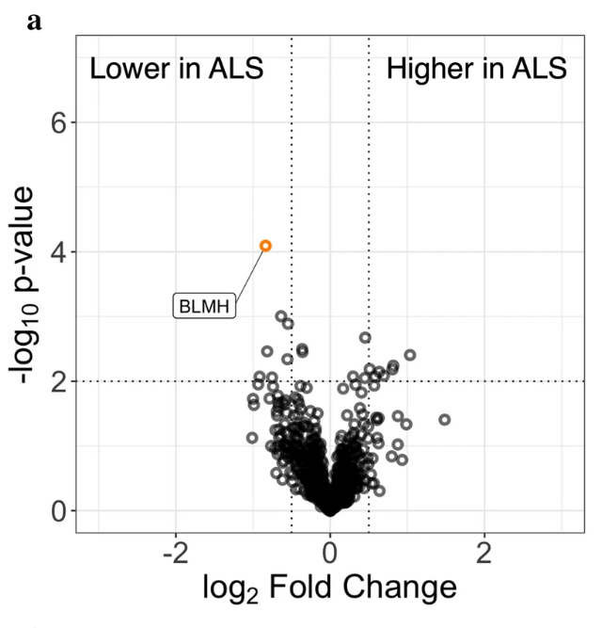
Mine analyses: Student’s t-test
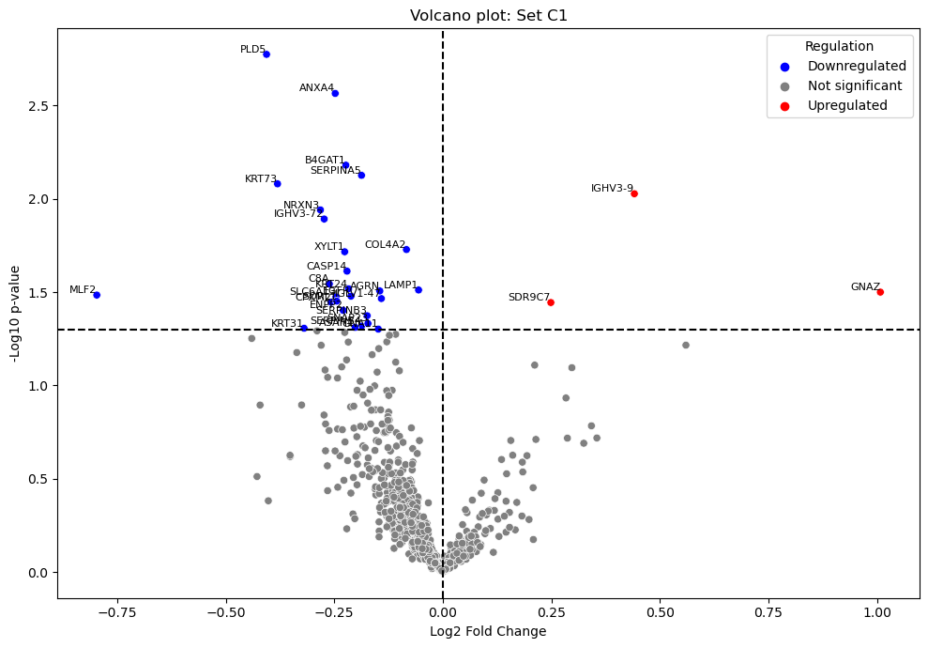

Dataset C2: No volcano plot by the author
Dataset C3:
Author: Kruskal- Wallis
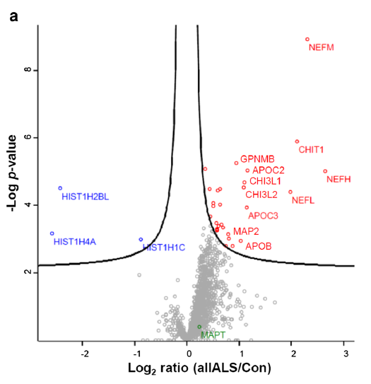
Mine analyses: NONE, used author’s as only aggregated data was available
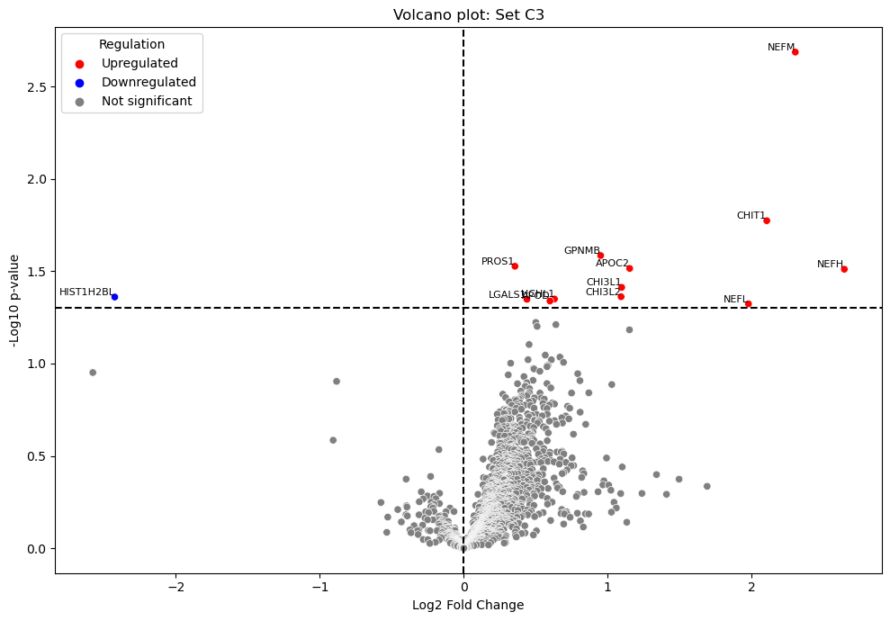

Dataset B4: compares fast vs slow ALS progression, so I cannot compare

Dataset S5:
Author: Student’s t-test

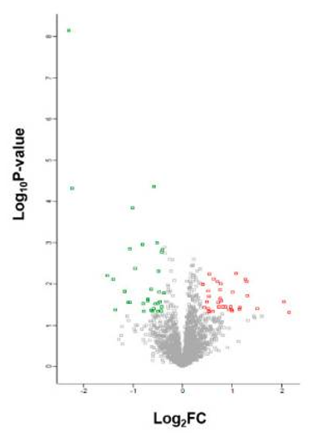
Mine analyses: Student’s t-test

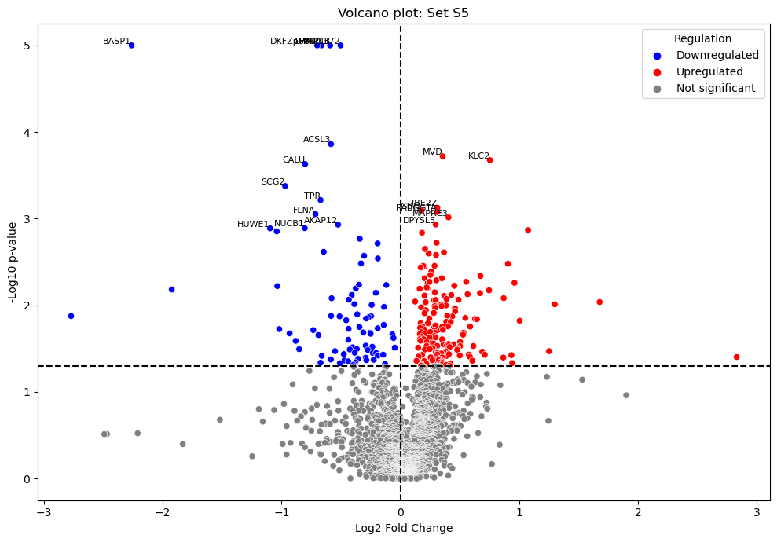
Dataset C6: No volcano plot by the author
Dataset B7: compares PD with ALS or PD with Control, so cannot compare
Dataset C8 : No volcano plot by the author
Dataset C9:
Author: Mann-Whitney U-test
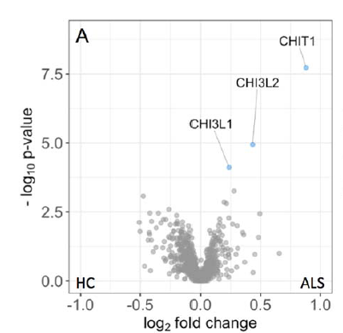
Mine analyses: Mann-Whitney

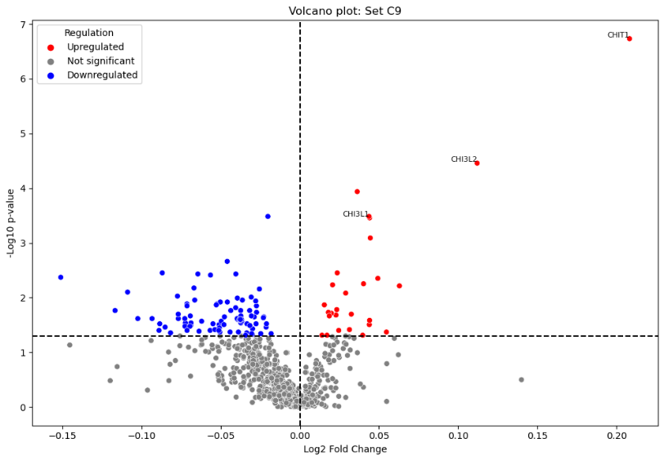
Dataset B10:
Author: Student’s t-test
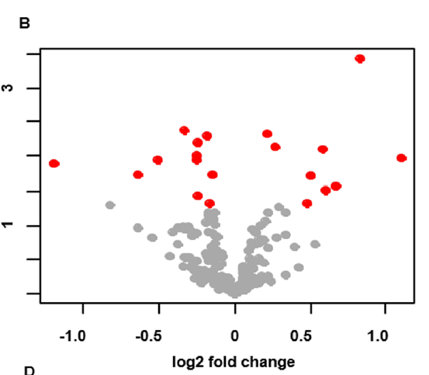
Mine analyses: Mann-Whitney
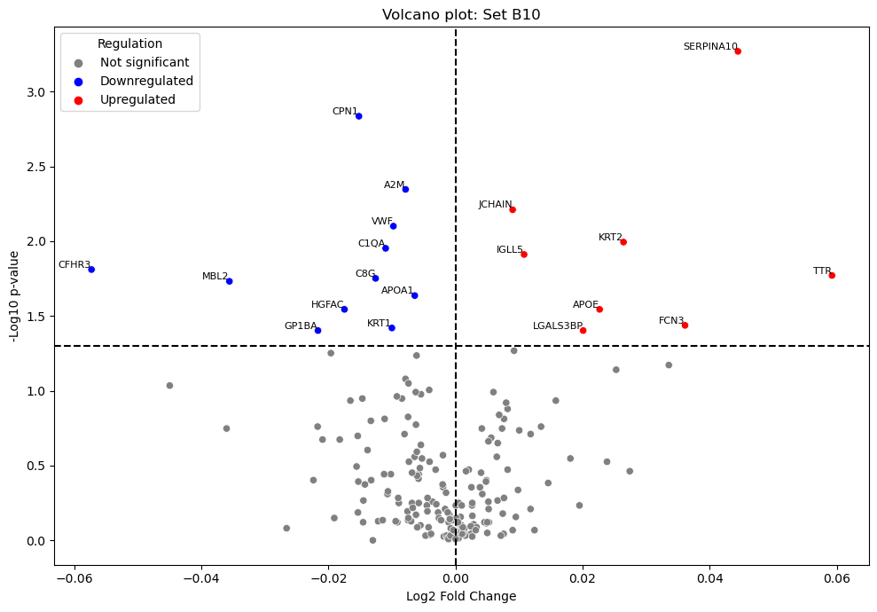

Dataset S11:
Author: Student’s t-test; Benjamini-Hochberg correction
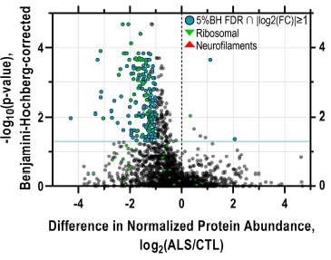
Mine analyses: Student’s t-test, No Benjamini-Hochberg correction
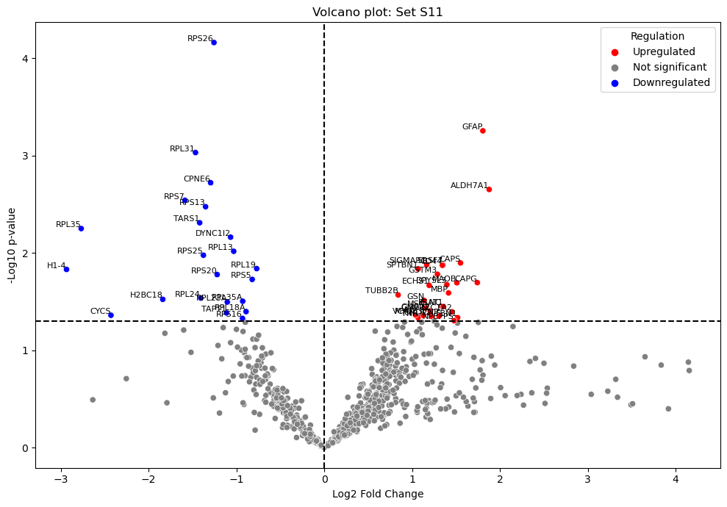

Dataset C12:
Author: Student’s t-test
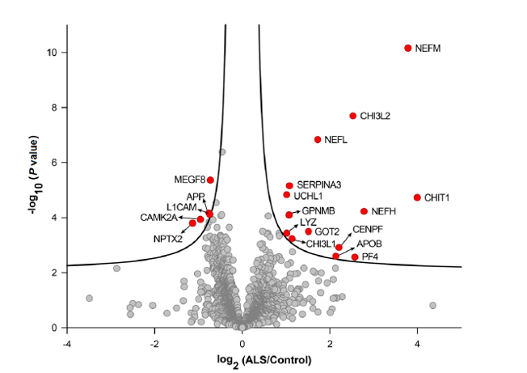

Mine analyses: Student’s t-test
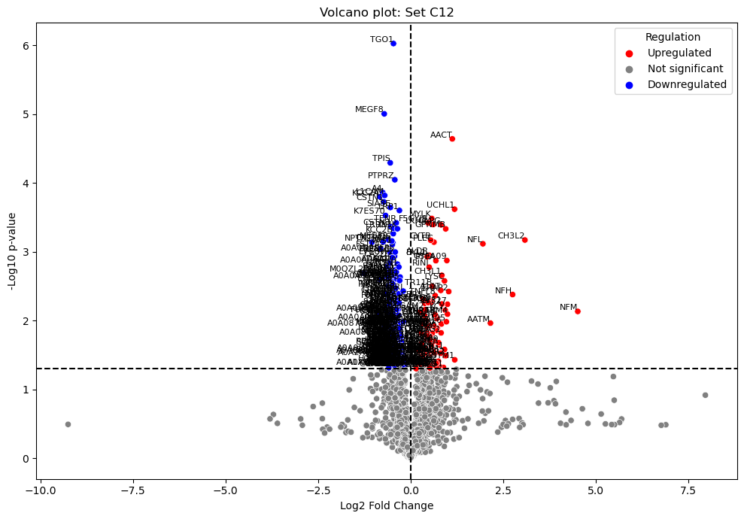
Dataset C13: looked for bulbar onset VS control and Spinal onset vs control

Dataset L14:
Author: Student’s t-test

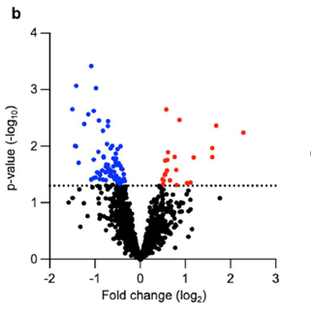
Mine analyses: Mann-Whitney
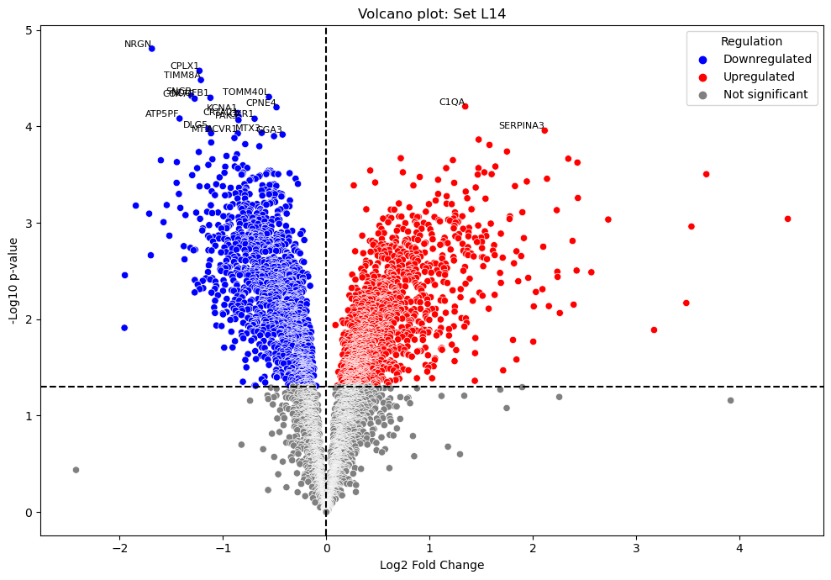
L15 no figures as used Answer ALS database, not an article

